CHAPTER 2
LITERATURE REVIEW

1. Transistor: Fundamentals
1.1. The Basic MIS structure
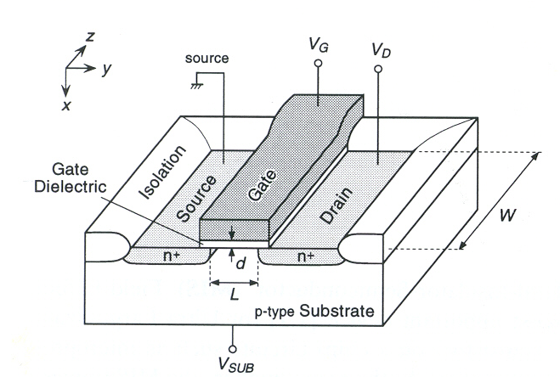
The Metal-Insulator-Semiconductor (MIS, MOS)) Field-Effect Transistor (FET) is the most important device for Ultra-large-Scale-Integration (ULSI>10⁷ transistors on a chip). As the name implies, the MIS transistor consists of a semiconductor substrate and a top gate electrode, between which an insulating gate dielectric film of thickness d is formed (Fig 1). Source and drain junctions are fabricated with a small overlap to the gate, between which an inversion layer called a channel of length L is formed, and carriers (electrons in this case of a n-channel FET) can flow when applied gate voltage V_{G} is sufficiently large, and vice versa.
Figure. 1 Schematic MIS transistor, which is alternatively called “MOS” since silicon oxide has been used as gate-dielectric film.¹

1.2 Ideal MIS structure
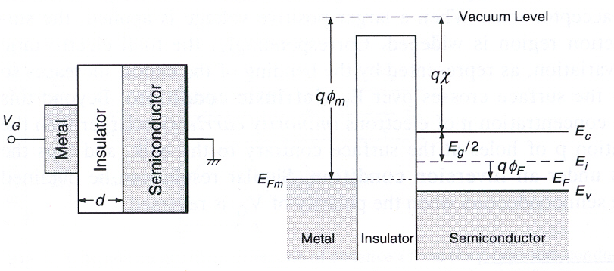
A MIS structure is shown in Fig. 2, with d being the thickness of the insulator and V_{G} the applied voltage on the gate metal. In the ideal case, the work function difference φ_{ms} between the gate metal and the semiconductor is zero:
Figure 2. Schematic cross section (left) and energy band diagram (right) of an ideal MIS capacitor at V_{G} = 0.²
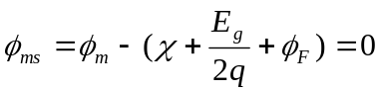 (1)
Where φ_{m} is the work function of the metal, χ is the electron affinity of the semiconductor, E_{G} is the band gap, and q the elementary charge. In this case, when no gate voltage is applied, the Fermi level E_{F}, considered as the electrochemical potential of the electrons, of the semiconductor coincides with the Fermi level E_{FM} of the metal, and thus the band is flat.
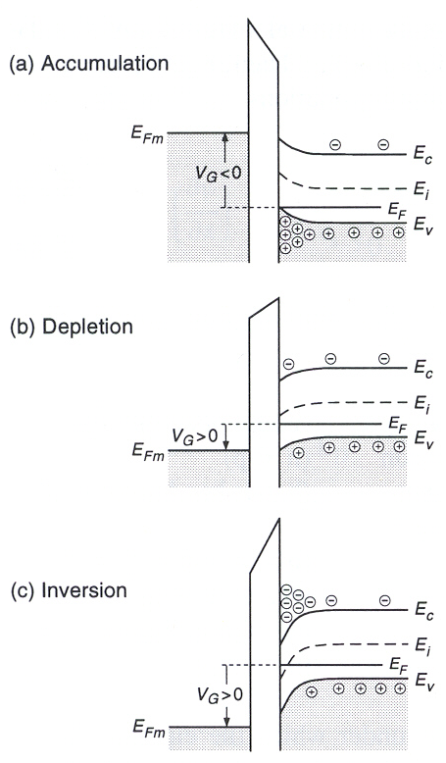
As schematically shown in Fig 3, when the structure shown in Fig 2 is biased with V_{G} ≠ 0, basically three situations may arise at the semiconductor surface. Regardless of V_{G}, E_{F} remains constant throughout the semiconductor since no current flow, holding equilibrium. When V_{G} < 0, the negative potential attracts positive charges in the semiconductor (Fig 3a); this result in an accumulation of holes (majority carriers) near the semiconductor. When a small positive voltage (V_{G} > 0) is applied, negative charges are introduced in the semiconductor (Fig 3b). This at first is due to holes being pushed away from the surface, leaving behind a depletion region consisting of uncompensated acceptor ions. When larger positive voltage is applied, this surface depletion is widened. Correspondingly, the total electrostatic potential variation, as represented by the bending of the bands, increases so that E_{i} at the surface crosses over E_{F}. This is called the intrinsic condition. Beyond this point, the concentration n of electrons (minority carriers) is larger than the concentration p of holes at the surface contrary to the bulk, and thus the surface is under an inversion condition (Fig 3c). Similar results can be obtained for n-type semiconductors when polarity of V_{G} is inversed.
Figure 3. Energy band diagrams of an ideal MIS capacitor with p-type semiconductor at VG ≠ 0 for a) accumulation, b) depletion and c) inversion conditions.²
The previously explained MIS electrical behavior is the basis for the microelectronic industry. In the following sections some important components of this MIS structures will be discussed, essentially a extremely important component: the gate dielectric.

2. The insulator in MIS structures: Gate Dielectrics
2.1 SiO₂ and SiON
Nature has gifted the silicon microelectronics industry with a fantastic material, SiO₂. SiO₂ is native to Si and forms a low defect density interface. It also has high resistivity, excellent dielectric strength, a large band gap, and a high melting point. These properties are highly responsible for enabling the microelectronics revolution.
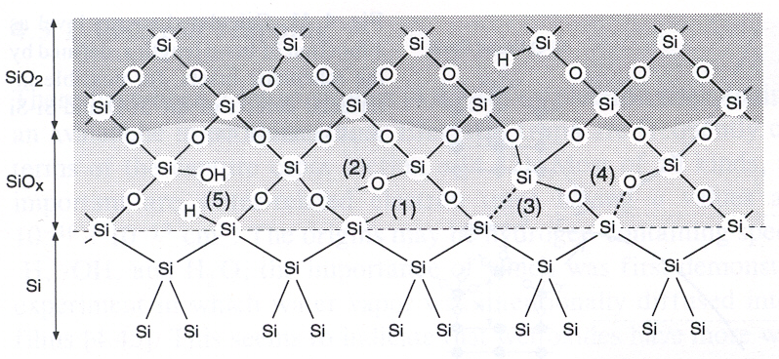
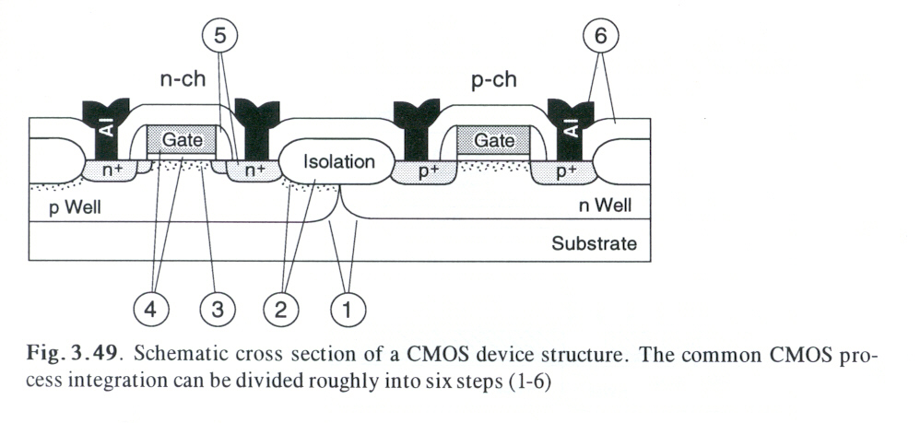
The Si/SiO₂ interface, which forms the heart of the MOS-FET (or MIS-FET) gate structure shown in Fig 4, is probably the world most economically and technologically important materials interface. Indeed, other semiconductors such as Ge or GaAs were not selected as the semiconducting material of choice, mainly due to their lack of a stable
Figure 4. Structure of the Si/SiO₂ interface. Some defects are also shown. 1) Si dangling bond, 2) non-bridging oxygen bond, 3) weak Si-Si bond, 4) strained Si-O bond, and 5) Hydrogen containing species.¹
Figure 5. Schematic illustration of a CMOS-FET: complementary metal–oxide field
effect transitor.³
native oxide and alow defect density interface. The metal–oxide–semiconductor field effect transistor MOS-FET, Fig. 5, is the building block of the integrated circuit. The ease of fabrication of SiO₂ gate dielectrics and the passivated Si/SiO₂ interface that results have made this possible. In spite of its many attributes, however, SiO₂ suffers from a relatively low dielectric constant (κ ~ 3.9).
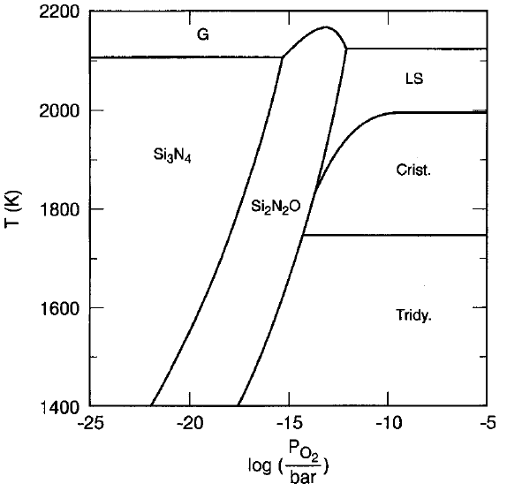
The concerns regarding high leakage current, B penetration, and reliability in ultra thin SiO₂ have led to materials structures such as oxynitrides (Si-O-N). These films have essentially the same dielectric constant of SiO₂. Error: Reference source not found The main advantage of oxynitrides is the protection against B and other impurities penetration through the gate dielectric.Error: Reference source not found,
Figure 6 Thermodynamic phase diagram (bulk) of the Si-O-N system.⁴
The phase diagram of the Si-O-N system (Fig 6) consists of four phases: Si, SiO₂, Si₃N₄ and Si₂N₂O. Under equilibrium conditions, the Si₃N₄ and SiO₂ never coexist. At chemical equilibrium, N should not incorporate into a SiO₂ film. However, N containing SiO₂ films a have been grown on Si.
Two reasons for the presence of N have been given.Error: Reference source not found-Error: Reference source not found- First, N atoms may simply be kinetically trapped at the reaction zone near the interface, and thus the N is present in a non-equilibrium state. Here is assumed that the N is incorporated into the film during oxynitridation and reacts only with Si-Si bonds at or near the interface, not with the Si-O bonds in the SiO₂ layer. The second explanation is that the N at the interface may indeed be thermodynamically stable, due to the presence of free energy terms not represented on the bulk diagram.
Brown et. al demonstrated that the dielectric constant of oxynitrides increases linearly with the N content in the SiO₂ film. Due to the higher κ of Si₃N₄ (~7.5)Error: Reference source not found oxynitrides films having the same capacitance as a SiO₂ film will be physically thicker, improving leakage current and dopant penetration resistance. However a major drawback must also be taken into account: increasing the N content also decreases the band gap, decreasing the barrier height for electron and hole tunneling. This compromises the reduced leakage current from the physically thicker film.
Another important property of Si-O-N films is their ability to act as a diffusion barrier to impurities (such as B, P and As from the poly-crystalline silicon gate).⁻ This is mostly due to the physically thicker dielectric film.

2.2 The need for alternate gate dielectrics
High gate dielectric capacitance is necessary to produce the required drive currents for sub-micron devices, and since capacitance is inversely proportional to gate dielectric thickness, the dielectric layers have been gradually scaled to thinner dimensions according to equation 1,
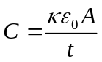 (2)
Where κ is the dielectric constant, also known as dielectric permittivity of the material. ε₀ is the permittivity of free space (8.85×10⁻³ fF/μm), A is the area of the capacitor, and t is the thickness of the dielectric.
Higher capacitance can be achieved by modifying the following: decreasing the dielectric thickness (t), increasing the capacitor area, (nor feasible), or finding a dielectric material with k higher than SiO2 or SiON.
The drive current associated with the scaling of logic device dimensions (see Fig 1) can be seen by considering equation 2.Error: Reference source not found
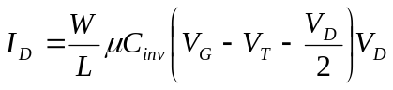 (3)
Where W is the width of the transistor channel, L is the channel length, μ is the channel carrier mobility, C_{inv} is the capacitance density associated with the gate dielectric when the underlying channel is in the inverted state, V_{G} and V_{D} are the voltages applied to the transistor gate and drain, respectively; the threshold voltage is given by V_{T}.
Since high gate dielectric capacitance is necessary to produce the required drive currents (Eq. 3) for submicron devices, and further since capacitance is inversely
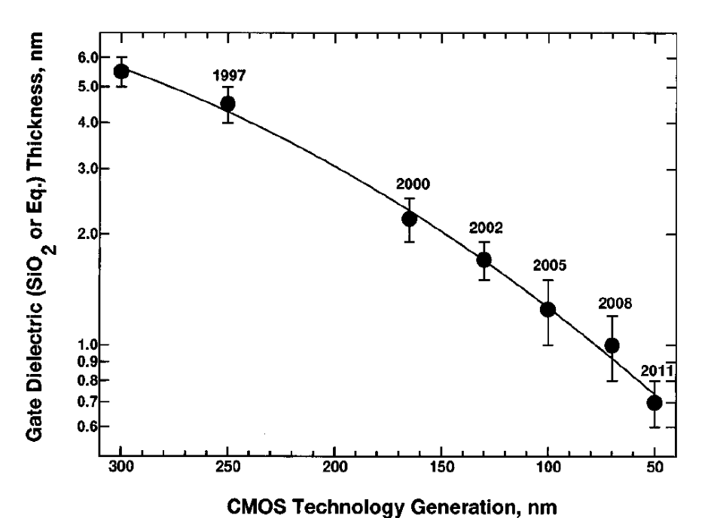
proportional to gate dielectric thickness (Eq. 1), the dielectric layers (i.e. SiO₂ and SiON) have been scaled to ever thinner dimensions, as is shown in Fig. 7. This gives rise to a number of problems, including impurity penetration through the dielectric film, enhanced scattering of carriers in channel, possible reliability degradation, high gate leakage current etc.
Figure 7. Decrease in gate SiO₂ thickness with device scaling technology generation vs. actual or expected year of implementation of each technology generation¹⁶
This continuous need to increase integrated circuit performance through shrinkage of the circuit elements has produced the scaling of the dimensions of MOSFET’s and other devices. This has been since the advent of integrated circuits about 40 years ago. According to a trend known as Moore’s law the exponential growth of chip complexity
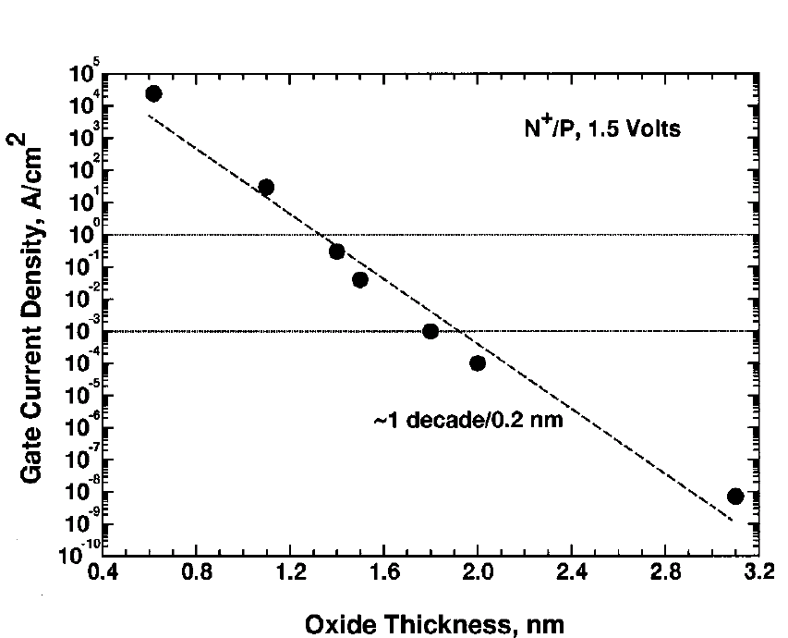
due to decreasing minimum feature size is accompanied by concurrent improvements in circuit speed, memory capacity, and cost per bit. To maintain the high drive current and gate capacitance required of scaled MOSFETs SiO₂ gate dielectrics have decreased in thickness from hundreds of nanometers 40 years ago to less than 2 nm today. Further, as can be seen in Fig. 8, SiO₂ (or SiON gate dielectric thickness) thickness continues to shrink. Many ultra small transistors have been reported, with SiO₂ layers as thin as 0.8 nm.⁻ In fact, the International Technology Roadmap for SemiconductorsError: Reference source not found predicts that SiO₂ gate dielectrics of 1 nm or less will be required within 10years. SiO₂ layers thinner than1.2 nm may not have the insulating properties required of a gate dielectric. Therefore alternate gate dielectric materials, having ‘‘equivalent oxide thickness’’ less than 1.2 nm may be used. Error: Reference source not found,Error: Reference source not found,
Fig 8. Gate leakage current measured at 1.5 V as a function of oxide thickness for 35 nm NMOSFETs. Leakage current increases one order of magnitude for every 0.2 nm decrease in SiO2 thickness. Horizontal lines indicate 1 A/cm 2 acceptable leakage current for desktop applications, and 1 mA/cm 2 acceptable leakage for portable applications³

2.3 Equivalent oxide thickness definition
Equivalent oxide thickness, (t_{eq}, EOT) is the thickness of the SiO₂ layer κ ~3.9 having the same capacitance as a given thickness of an alternate dielectric layer.
Equation 2 can be rewritten in terms of t_{eq} as mentioned this represents the theoretical thickness of SiO₂ that would be required to achieve the same capacitance density as the alternate dielectric and is given by:Error: Reference source not found
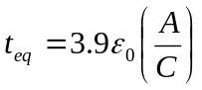 (4)
For example, if a SiO₂ capacitor is used, and assuming that 10 Å of this film produces a capacitance density of (C/A) = 34.5 fF/μm², thus the physical thickness of an alternate dielectric that must be used in order to achieve the same capacitance density is given by:Error: Reference source not found
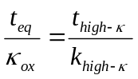 (5)
Eq. 5 can be rearranged as:
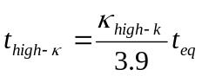 (6)
Where 3.9 is κ_{SiO2}. Therefore, an alternate gate dielectric with a relative permittivity of 16 and physical thickness of 40Å can be used, to obtain t_{eq} ~ 10Å.

3. Alternate gate dielectrics: required materials properties
The fundamental limits imposed on SiO₂ (SiON) are the excessive high leakage current, reduced drive current, and reliability.Error: Reference source not found The first two of these properties impose a limit of ~ 13Å as the thinnest SiO₂ acceptable. According with [Error: Reference source not found] the SiO₂ (or SiON), will have to be replaced by in as little as 4-5 years (2006).
As an alternative to SiO₂/SiON systems, much work has been done on materials with higher k that can provide higher drive current, while keeping the leakage current low. The following section discusses the desired materials properties of alternate gate dielectrics. The only disadvantage of SiO₂ is its low κ. The only advantage of alternate gate dielectrics is only one: their high κ.
Key materials properties of any new high-κ material include high permittivity, barrier high properties to prevent tunneling, stability in direct contact with silicon, good interface quality, good film morphology, gate compatibility, process compatibility and reliability. Below, a brief discussion of each of these is shown.

3.1. Permittivity and barrier height
Selecting a gate dielectric with a higher permittivity (κ) than 3.9 (SiO₂), is clearly essential. One of the drawbacks in measuring κ in alternate dielectrics is the available data on κ values. Most of then data available is for bulk materials, however much more experimental data is needed for measurements of dielectric constant for gate dielectric films thinner than ~ 100 Å.Error: Reference source not found
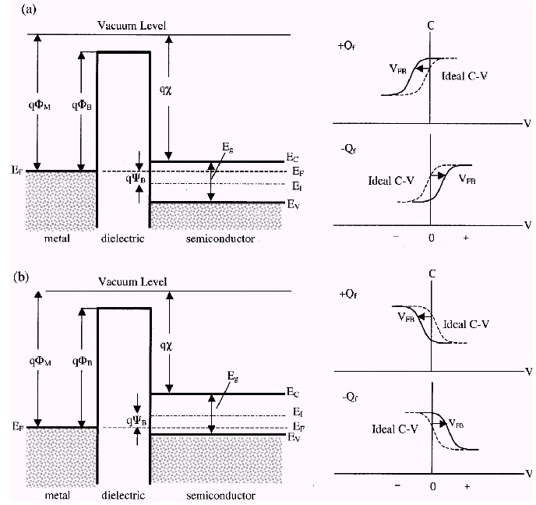
The required permittivity must be balanced against the barrier height in order to limit the tunneling process., For electrons traveling from the silicon substrate to the gate, this is the conduction band offset, ΔE_{C} ≈ q[χ-(Φ_{M}-Φ_{B})]. (Fig 8); for electrons traveling from the gate to the Si substrate, this is Φ_{B}. This is because leakage current increases exponentially with decreasing barrier height (and thickness), for a direct tunneling process this is:Error: Reference source not found,Error: Reference source not found
Figure 8 Energy-band diagrams and associated high-frequency C– V curves for ideal MIS diodes for a) n-type and b) p-type semiconductor substrates. For these ideal diodes, V=0 corresponds to a flatband condition. For dielectrics with positive (+Q_{f}) or negative (-Q_{f} ) fixed charge, an applied voltage (V FB ) is required to obtain a flatband condition and the corresponding C– V curve shifts in proportion to the fixed charge

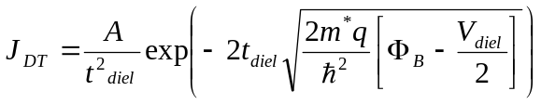 (7)

Here A is a constant, t_{diel} is the physical thickness of the dielectric, V_{diel} is the voltage drop across the dielectric, and m* is the electron effective mass in the dielectric.
For highly defective films, electron transport will instead be dominated by trap-assisted mechanism such as the Frenkel-Poole emission (Eq. 8) or hopping conduction (Eq. 9), as described by:
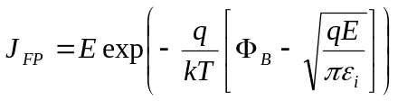 (8)
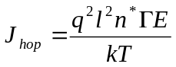 (9)

Here l is the interval of separation between adjacent hopping sites, n* is the density of free electrons in the dielectric, and Γ is the mean hopping frequency.
A gate dielectric must have a sufficient ΔE_{C} value to the polysilicon gate, and to other gate materials, in order to obtain low off-state currents (leakage current). If ΔE_{C} is < 1.0 eV, it will likely prevent the oxide’s use in gate dielectric applications because thermal emission or tunneling would lead to unacceptably high leakage current.

Most potential gate dielectrics do not have reported ΔE_{C} values; the closest indicator is the band gap (E_{G}) of the dielectric. Generally, large E_{G} corresponds to large ΔE_{C}. However, some materials have large valence band offset, ΔE_{V}, which constitutes most of the dielectric’s band gap.
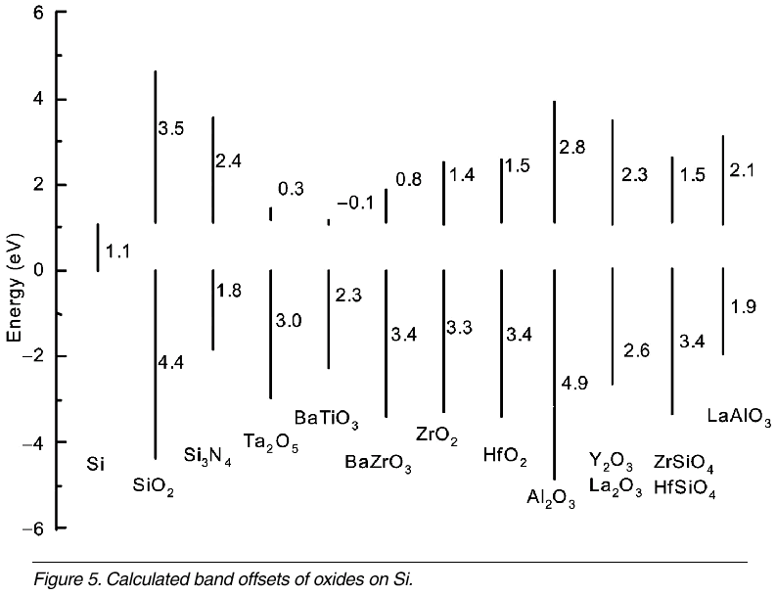
Calculated Band offsets are shown in Fig 9. The oxides of Zr, Hf, La, Y, and Al and their silicates all have conduction band offsets of >1eV.
Figure 9 Calculated Band offsets for oxide in Si²⁴
There are two main contributions to the dielectric constant: electronic and ionic dipoles. Figure 10 illustrates the frequency ranges were each contribution is important. In general, atoms with a large ionic radius (high atomic number) exhibit more electron dipole response to an external electric field. This is because there are more electrons to respond to the field. This electronic contribution is the main reason for the higher permittivity of oxides with higher atomic number.
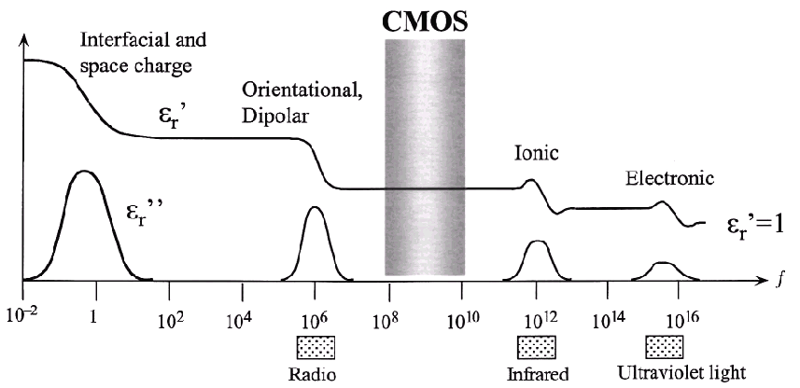
The ionic contribution to the permittivity can be much larger than the electronic portion in cases such as perovskite crystals. For instance in the (Ba, Sr)TiO₃ case the Ti ions in unit cells throughout the crystal are uniformly displaced in response to an applied electric field, this is because the Ti ions reside in one of two stable, nonisosymmetric positions about the center of the Ti–O octahedra. This displacement of Ti ions causes an enormous polarization in the material, and thus can give rise to very large dielectric constants of 2000–3000. Since ions respond more slowly than electrons to an applied field, the ionic contribution begins to decrease at very high frequencies, in the infrared range of ~10¹² Hz, as shown in Fig. 10.
Fig 10. The frequency dependence of the real (εr’) and imaginary (εr’’) parts of the dielectric permittivity. In CMOS devices, ionic and electronic contributions are present.²⁵
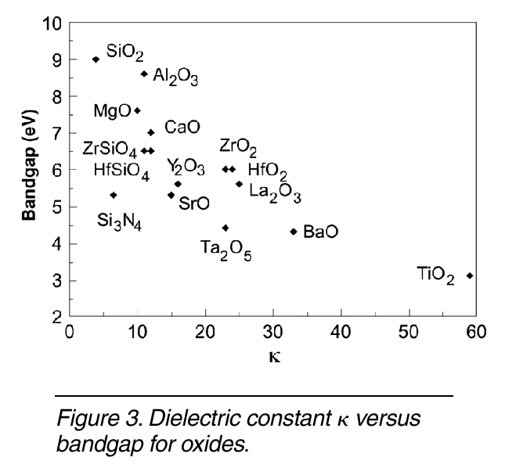
Some of the potential candidate materials may have other contributions to the permittivity, which do not exhibit the same phenomena as the perovskites. The addition of certain levels of network modifier ions such as Zr or Hf to materials such as SiO₂ can produce an increased dielectric constant even at low incorporation levels, through a discernable change in the bond order of the material. Experimentally, κ varies roughly inversely with band gap (Fig 11).Error: Reference source not found Stability and band offset requirements tend to restrict us to oxides with a sizable band gap and a rather small dielectric constant.
Figure 11. Permittivity (κ) versus bandgap for oxides.²⁴

3.1.1Factors affecting κ
The low frequency dielectric constant is the sum of electronic and lattice contributions, κ = κ_{e} + κ_{l}. The electronic component is also the optical dielectric constant ε∞, and it is given by the refractive index squared, κ_{e} = ε∞ =n². Values of ε∞for the oxides are typically 4–5 and do not exceed 8. This is small, so the major contribution to κ must be from the lattice, κ_{l} which is related to microscopic parameters asError: Reference source not found
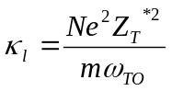 (10)
Where N is the number of ions per unit volume, e is the electronic charge, Z_{T}* is the transverse effective charge, m is the reduced mass, and ω_{TO} is the frequency of the transverse optical phonon. Large values of κ_{l} arise for small ω_{TO} in solids with a low frequency or soft-phonon mode. A negative value of ω_{TO} corresponds to ferroelectricity.
It is popular to treat κ as the sum of atomic or ionic polarizabilities when searching for new oxides or when treating the κ of alloys.
The susceptibility, χ = κ−1 is the ratio of polarization vector P to the applied electric field E. The susceptibility can be thought of as the sum of individual contributions from each atom or bonding unit. More formally, an atom or ion polarizability α is defined as the ratio of a dipole moment to a local electric field, E_{loc}. The local field differs from the applied field; it is the field in a spherical hole in the solid and is given by E_{loc}=E – P/(3ε₀). This leads to the Clausius–Mosotti relation for the ion types:
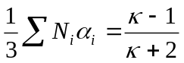 (11)
Here, N is the numbers of ions of type i per unit volume. To use this in a new system or an alloy such as a silicate, we must know how the ion coordination vary, as this determines the ion density N. N varies roughly with coordination, except that bond lengths tend to increase slightly for high coordination. Eq 11 means that dielectric constants are not always linear interpolations of the end members.

3.2 High-κ gate dielectric stability in contact with Silicon
Many dielectrics are known with κ > 3.9. However, there is a significant driving force for most dielectrics to react with Si; that is, most dielectrics are not thermodynamically stable in contact with Si. It is possible to limit the extent on the reaction by introducing an interfacial barrier; however, concerns regarding reaction at high annealing temperatures still exist.Error: Reference source not found,Error: Reference source not found Furthermore, the interface layer plays a determining role in the resulting electrical properties of the stack. See Fig 12.
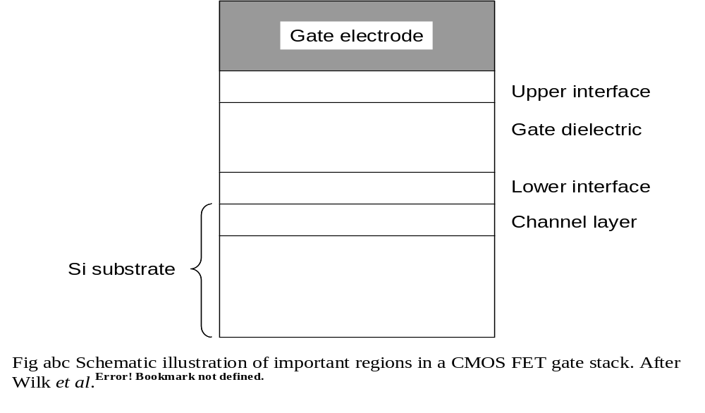
Figure 12. The effect of a lower κ interface (near the SI surface) limits the total capacitance achieved with the new high-κ material.
For all thin gate dielectrics, the interface with Si plays a key role in determining the overall electrical properties. Many of the high-κ metal oxide systems investigated so far have unstable interfaces with Si: they react with Si to form an undesirable interfacial layer and require a reaction barrier. Using an interfacial layer of another low-permittivity material will limit the highest possible gate stack capacitance, or equivalently the lowest achievable t_{eq} value.
When the stack-structure contains several dielectrics in series, the lowest capacitance layer will dominate the overall capacitance and also will set a limit on the
minimum achievable t_{eq} value. The total capacitance of two dielectrics in series (see Fig 12) is given by:
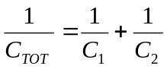 (12)
Where C₁ and C₂ are the capacitances of the two layers, respectively. If one considers a dielectric stack structure such that the shown in Fig abcd, and if the bottom layer (interfacial layer) of the stack is SiO₂, and the top layer (layer 2) is the high-κ alternative gate dielectric, Eq. 2 is simplified (assuming equal areas) to:
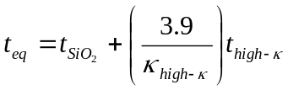 (13)
It is clear that the minimum achievable t_{eq} (EOT) will never be less than that of the lower-κ (in this case, pure SiO₂) layer. Therefore, the expected increase in the gate capacitance associated with the high-κ dielectric is compromised. This is illustrated in Figure 13 for idealized gate stack structures. It can be seen that both stacks result in t_{eq} 10 Å, each with layers that have very different values.
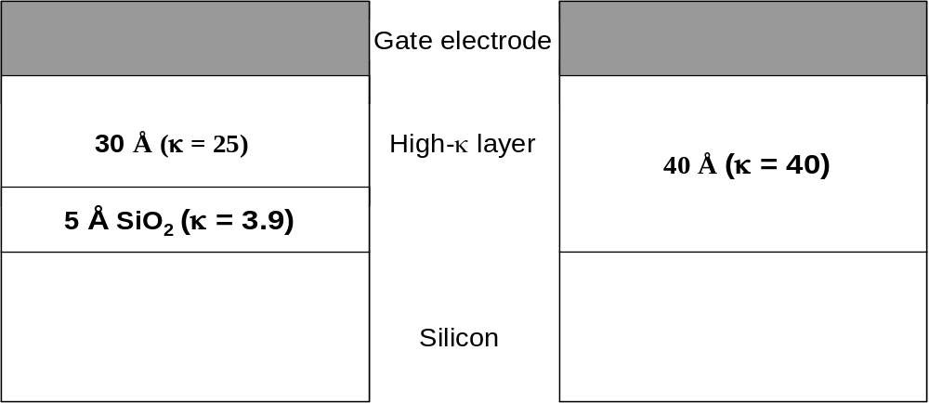
B)

Figure 13. Comparison of (a) stacked and (b) single-layer gate dielectrics. Both structures results in the same overall gate stack capacitance or equivalent oxide¹⁵ thickness, t_{eq} 10 Å.¹⁵
Ta₂O₅ and TiO₂ are predicted and are observed to phase-separate into SiO₂ and
metal oxide, and possibly silicide phases upon annealing and can therefore likely be ruled out as viable gate dielectric candidates., In contrast phase diagrams for the Zr (Hf) -Si-O system indicate that the metal oxide ZrO₂ and the compound silicate ZrSiO₄ are predicted to both be stable in direct contact with Si up to high temperatures.Error: Reference source not found
An important approach toward predicting and understanding the relative stability of a particular three-component system for device applications can be explained through ternary phase diagrams., For a binary oxide to be stable in contact with silicon, a tie line must exist between the or nitride and silicon, as shown in Fig 14.
For exampleError: Reference source not found, iron (Fe) has three binary oxides that are solid at 1000K; FeO, Fe₃O₄, and Fe₂O₃, but all these have ΔG<0 for the reaction Si + MO_{x} → M + SiO₂. This
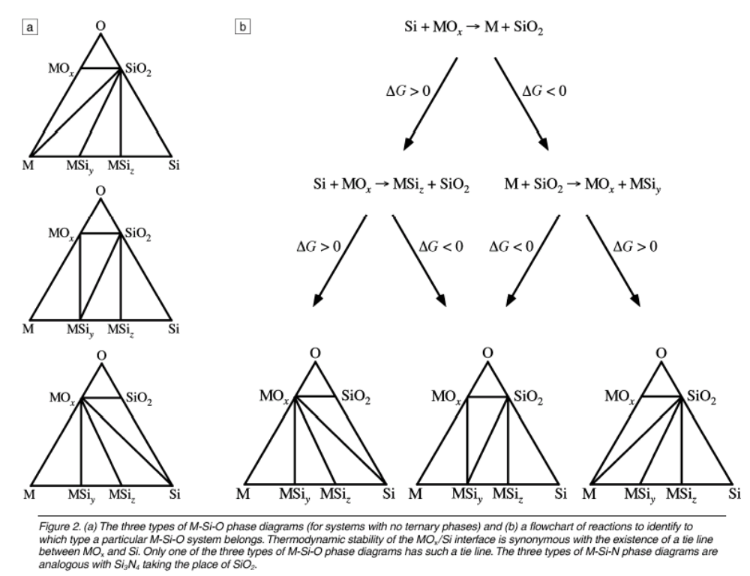
Figure 14 (a) The three types of M-Si-O phase diagrams (for systems with no ternary phases) and (b) a flowchart of reactions to identify to which type a particular M-Si-O system belongs. Thermodynamic stability of the MO_{x} /Si interface is synonymous with the existence of a tie line between MO_{x} and Si.²⁹
indicate that none of these oxides are not thermodynamically stable in contact with Si at 1000 K,
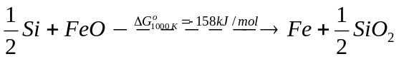 (14a)
(14b)
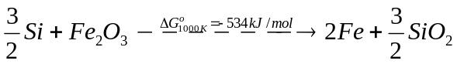 (14c)
A thermodynamically stable binary oxide in contact with Si is ZrO₂.
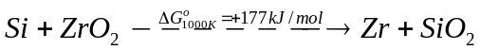 (15a)
(15b)
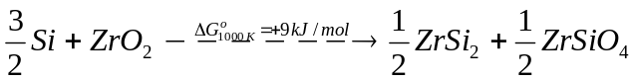 (15c)
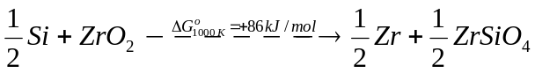 (15d)
It is important to realize that even when one is working with an alternative gate dielectric that is thermodynamically stable with Si (as predicted by free energy calculations), such a dielectric/Si interface in not stable under all processing conditions. Unwanted reactions can occur if processing occurs in excess of oxygen, reducing environment, etc. Such reactions will likely result in dielectric film decomposition, with a possible by-product than might react with Si.

3.3 Interface quality
The SiO₂/Si interface (shown in Fig 3) is almost perfect. It has midgap interface-state density D_{it} ~ 2×10¹⁰ states/cm² eV.Error: Reference source not found Most of the of the high-k reported show D_{it} ~ 10¹¹ - 10¹² states/cm² eV, with flatband voltage shift ΔV_{FB} > 300 mV.Error: Reference source not found
An interesting approach to study the Si/high-κ interface is to use the average number of bonds per atom. According to ref [Error: Reference source not found] if the average number of bonds per atom N_{av}>3, the interface defect density increases proportionally. Metal oxides which contain elements with a high coordination (such as Ta and Ti) will have a high N_{av}, and form an overconstrained interface with Si. This will produce degradation in leakage, current and electron channel mobility. Similarly, cations with low coordination (Ba, Ca) compared to that of Si lead to underconstrained systems in the corresponding metal oxides. These systems (metal oxides, ternary alloys, etc.) which are either over- or underconstrained with respect to SiO₂, lead to formation of a high density of electrical defects near the Si-dielectric interface, resulting in poor electrical properties.Error: Reference source not found
Any silicide bonding which forms near the channel interface will also tend to produce unfavorable bonding conditions, leading to poor leakage current and electron channel mobilities.
ZrO₂ and HfO₂ have been previously reported as having high oxygen diffusivities. This is a serious concern regarding control of the interface once it is initially formed. Any annealing treatments which have an excess of oxygen present will lead to rapid oxygen diffusion through the oxides, resulting in SiO₂ or SiO₂-containing interface layers (I.e. silicates).
Another annealing ambient of concern is forming gas (90% N₂ : 10% H₂), which is a standard final anneal in the CMOS process and is believed to passivate interfacial
traps, such as dangling bonds. This passivation is due to the reaction of H₂ with the non-satisfied Si- bonds, forming Si-H bonds. Since many high-κ dielectrics can be reduced in the presence of H₂, high-κ gate dielectrics also need to be characterized with respect to the effect of anneals in reducing ambient.
It is important no mention that it is very likely that any short-term solution will likely involve an interface comprised of several monolayers of Si–O (or Si-N) containing material layer, at the channel interface. This layer could serve to preserve the critical, high-quality nature of the SiO₂ interface; a different high- κ material could then be used on top of the interfacial layer.

3.4 Film morphology
One of the main drawbacks that most alternate gate dielectrics face is that they will crystallize under typical processing temperatures (~1000-1050 ºC). From leakage current perspective, it is desirable to have the alternate gate dielectric in the glassy phase. This phase will also improve dopant penetration properties. In addition, grain size and orientation changes throughout a polycrystalline film can cause significant variations in κ, leading to irreproducible properties.
Given the concerns regarding polycrystalline and single crystal films, it appears that an amorphous film structure is the ideal one for the gate dielectric. This is another clear virtue of SiO₂

3.5 Gate compatibility
A major issue for integrating any advanced gate dielectric into a standard CMOS device is that the dielectric should be compatible with both Si-based and metal gates. Si-based are desirable because dopant implant conditions can be tuned to create the desired threshold voltage V_{T} for both NMOS and PMOS (n-type channel MOS and p-type channel MOS) FETs, and the process-integration schemes are well established in industry. It is likely that many of the high-k gate dielectrics investigated to this point, however, require metal gates. This is expected because the same instability with Si, mentioned in Sec. 3.2, will exist at both the channel and the poly-Si gate interfaces.
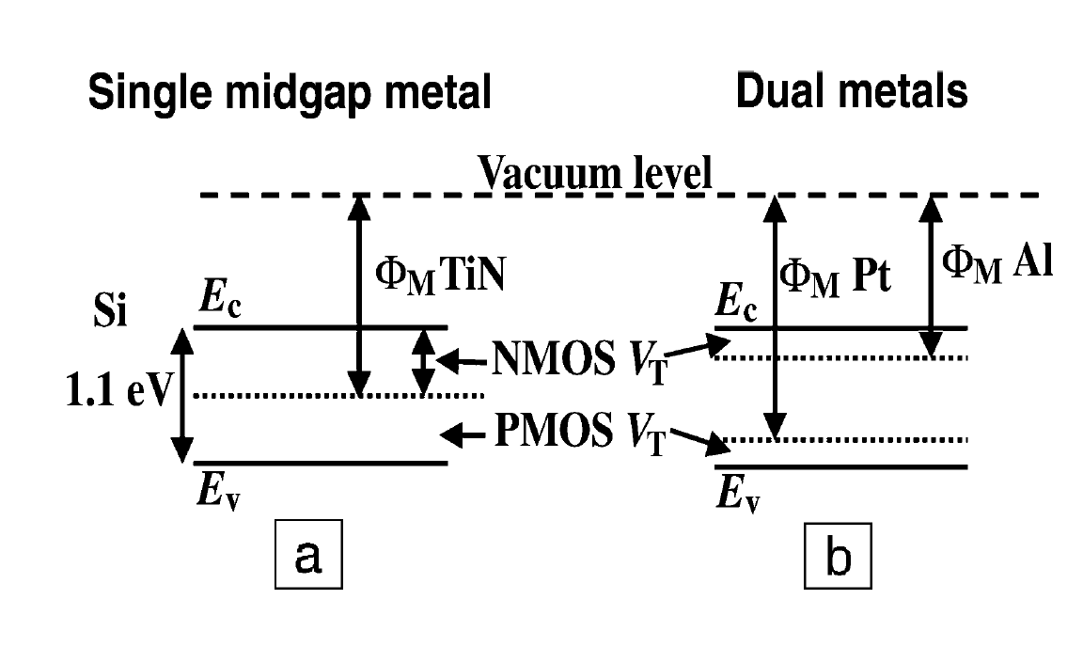
Metal gates are very desirable for eliminating dopant depletion effects and sheet resistance constraints. In addition, use of metal gates in a replacement gate process can lower the required thermal budget by eliminating the need for a dopant activation anneal in the poly-Si electrode. There are two basic approaches toward achieving successful insertion of metal electrodes: a single midgap metal or two separate metals. The energy diagrams associated with these two approaches are shown in Fig 15.
Figure 15 Energy diagrams of threshold voltages for NMOS and PMOS FET devices using (a) midgap metal gates and (b) dual metal gates. E_{c} is the conductance band, E_{v} is the valence band, Φ_{M} is the work function of the metal indicated, and V_{T} is the
threshold voltage.¹⁵
The first approach is to use a metal that has a work function that places its Fermi level at the midgap of the Si substrate, as shown in Fig. mmm a. These are generally referred to as ‘‘midgap metals.’’ The main advantage of employing a midgap metal arises from a symmetrical V_{T} value for both nMOS and pMOS, because by definition the same energy difference exists between the metal Fermi level and the conduction and valence bands of Si.
A major drawback of the midgap metal approach is that the bandgap of Si is fixed at 1.1 eV, thus the threshold voltage for any midgap metal on Si will be 0.5 V for both NMOS and PMOS devices. Since voltage supplies are expected to be 1.0 V for sub-0.13μm CMOS technology, V_{T} 0.5 V is much too large for future CMOS devices, as it would be difficult to achieve a reasonable gate overdrive (V_{G} - V_{T}) for the desired device performance.
A second approach (Figure 15) toward metal electrodes involves two separate metals, one for PMOS and one for NMOS devices. In the ideal case shown, the (work function of a metal M) value of could achieve V_{T} 0.2V for NMOS devices, while the higher M value of could achieve V_{T} 0.2V for PMOS devices.
A key issue for gate-electrode materials research will be the control of the gate-electrode work function (Fermi level) after further CMOS processing. It is likely that compositionally controlled metal gate alloys will be required to obtain the desired work function values.

3.6 Process compatibility
The deposition process for the dielectric must be compatible with current or expected CMOS processing, cost, and throughput. Most of the deposition techniques available occur under non equilibrium conditions, it is certainly possible to obtain properties different from those expected under equilibrium conditions is therefore important to consider the various methods for depositing the gate dielectrics.
Physical vapor deposition (PVD) methods have provided a convenient means to evaluate materials systems for alternate dielectric applications. The damage inherent in a sputter PVD process, however, results in surface damage and thereby creates unwanted interfacial states. For this reason, chemical vapor deposition (CVD) methods have proven to be quite successful in providing uniform coverage over complicated device topologies.
CVD deposition requires careful attention in order to control interfacial layer formation. The precursor employed in the deposition process must also be tailored to avoid unwanted impurities in the film as well as permit useful final compositions in the dielectric film.
Extremely high-κ dielectrics, such as SrTiO₃ have been deposited directly on Si using MBE; however, a manufacturability scaled CMOS process incorporating MBE methods remains a clear challenge, due to the inherent poor throughput.

3.6 Reliability
The electrical reliability of a new gate dielectric is critical for application in CMOS technology. The determination of whether or not a high-κ dielectric satisfies the strict reliability criteria requires a well-characterized materials system. The determination of the preferred dielectric materials has yet to be completed thus making even initial reliability extrapolations problematic.

4. Pseudobinary allows: Zr and Hf Silicate

Recently, pseudobinary alloys have been proposed as suitable for alternate gate dielectric applications. These materials have many advantages over regular binary oxides. A binary oxide is a material with two distinct oxide constituents that are intermixed, such as (MO₂)_{0.5}(SiO₂)_{0.5}, where M = Zr, Hf, Al, etc. [i.e., (ZrO₂)_{0.5}(SiO₂)_{0.5} →ZrSiO₄]. A pseudobinary mixture involves a stoichiometry that results in an amorphous (glassy) state, such as (HfO₂)_{x}(SiO₂)_{1-x}, for x<0.2.
Many materials (e.g., Ta₂O₅ and TiO₂) are predicted and are observed to phase separate into SiO₂ and metal oxide (M_{x}O_{y}, M metal), and possibly silicide (M_{x}Si_{y}) phases upon annealing. Therefore such materials are likely to be ruled out as viable gate dielectric candidates; even though they exhibit κ>3.9. In contrast to the Ta and Ti systems, phase diagrams for pseudobinary alloys, such as the Zr-Si-O system indicate that the metal oxide ZrO₂ and the compound silicate ZrSiO₄ are predicted to both be stable in direct contact with Si up to high temperatures (at least 900 ºC).
Recent work on two such systems of pseudobinariesError: Reference source not found3637 indicate that Zr and Hf
silicates exhibit encouraging gate dielectric properties. Both materials systems have the principle of mixing a high-κ metal oxide (ZrO₂, HfO₂) with an amorphous, stable, lower- κ material (SiO₂) or obtain a desirable morphology with suitable properties for a CMOS gate dielectric. ZrO₂:SiO₂ and HfO₂:SiO₂ silicates within an appropriate composition
ranges have been demonstrated to exhibit very low leakage currents and improved κ values with only small amounts of ZrO₂ or HfO₂ in the material.Error: Reference source not found
Figs. 16a and 16b show that there are no apparent thermodynamically stable ternary compounds for the Ta – Si – O and Ti – Si – O systems, glassy silicates
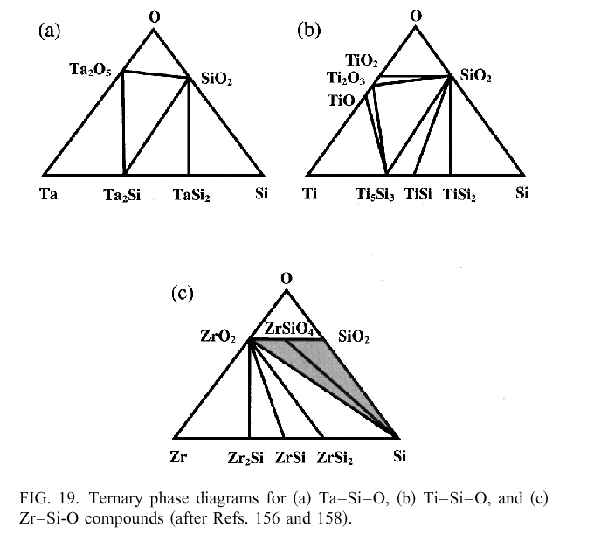
(Ta_{x}Si_{y}O_{z} or Ti_{x}Si_{y}O_{z}) of these materials may be obtained. The subsequent thermal processing that these materials experience will be of key importance, though, as these systems are likely to separate into more stable M_{x}O y and M_{x}Si_{y} phases.
Fig. 16. Ternary phase diagram for a) Ta – Si – O, b) Ti – Si – O, and c) Zr – Si – O.³⁶
In this dissertation, the work is focused in the Hf–Si–O and Zr–Si–O systems. One potentially large advantage for silicates is that this class of materials should have a silicate-Si interface that is chemically similar to the SiO₂–Si interface, in this way, the SiO₂/Si interface quality for transistor channel regions in maintained, while increasing κ.
This is especially important since the channel interface is playing a dominant role in determining device performance, and because almost any simple oxide (as discussed in

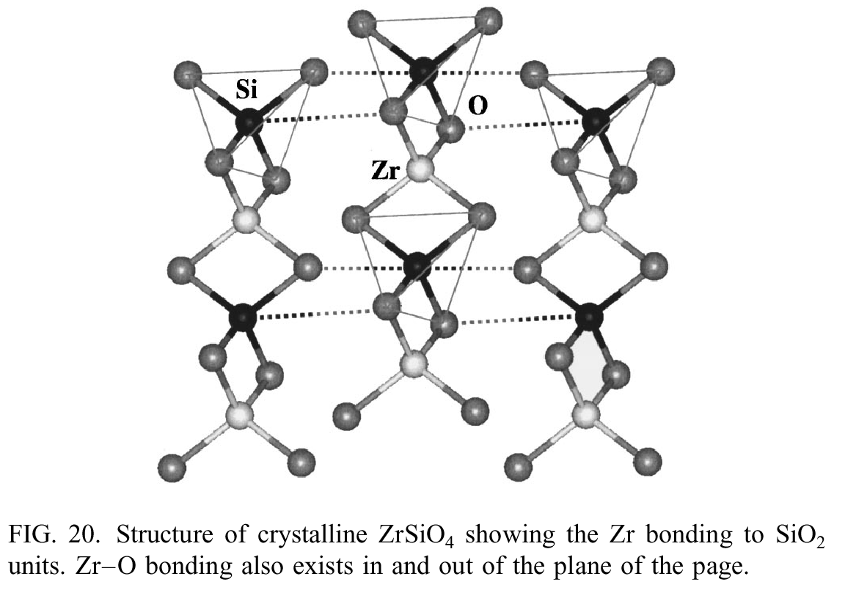
section 2.3) deposited on Si will form a silicate interfacial layer, even if it is very thin. The tetravalent transition metal cations such as Zr and Hf offer the advantage of
Figure 17 Structure of crystalline ZrSiO₄ showing the Zr bonding to SiO₂ units. Zr–O bonding also exists in and out of the plane of the page. After ref [36].
substituting well at Si sites, which form SiO₄ tetrahedra. For the case of forming nonstoichiometric silicates, such as (ZrO₂)_{x}(SiO₂)_{y} and (HfO₂)_{x}(SiO₂)_{y}, where x and y are not integers. A tetravalent cation such as Zr⁴⁺ or Hf⁴⁺ ions should substitute well for Si⁴⁺ , to provide a favorable bonding for a silicate network with low defect densities.
The Bravais lattice for the stoichiometric compound ZrSiO₄ is body-centered tetragonal, and belongs to point group D 4h., The crystal is composed of SiO₄ tetrahedra interspersed with Zr atoms, but can be considered as parallel chains of ZrO₂ and SiO₂ structural unit molecules, as shown in Fig. 17. Each Zr and Si atom shares bonds to four O atoms within each chain, and each successive pair of O atoms is oriented in a transverse configuration, forming ZrO₂ and SiO₂ units. The Si–O bond length is shorter than the Zr–O bond length within a chain, as is represented in the figure. Figure 20 show that each Zr atom also shares bonds with other O atoms in neighboring chains, providing a three-dimensional stability to the material. It is important to note that each Zr and Si atom has only O atoms as nearest neighbors. Chemical analysis of homogeneous silicate films is therefore expected to show only Zr–O nearest neighbor bonding, with a slight effect from Si as a next-nearest neighbor. It is reasonable to assume that for Hf and Zr concentrations less than that of the stoichiometric MO₂ – SiO₂ compound, nearly all bonds will be Zr–O (or Hf–O) and Si–O bonds.Error: Reference source not found^{,36,37}
Using coordination chemistry arguments between Hf and Zr, HfSiO₄ should have the same structure as ZrSiO₄. A value of κ = 12.6 for bulk ZrSiO₄ was reported.Error: Reference source not found Since HfO² has reported values of κ = 21-25. A HfSiO₄ compound is expected to have a range of κ = 13– 20. The of κ will depend strongly on film composition, density and structure. For example, amorphous materials typically have less lattice polarizability than their crystalline counterparts yielding lower κ values. Considering all of the desired properties (ZrO2)_{x} (SiO₂)_{1-x} and (HfO₂)_{x}(SiO₂)_{1-x} should be excellent materials candidates for advanced gate dielectrics.

4.1Recent results on Zr and Hf silicate systems.
Wilk and Wallace suggested the first application of Zr and Hf silicates as alternate gate dielectric.Error: Reference source not found3637 In these papers, it was shown than a stable gate dielectric based on Zr and Hf silicates with a t_{eq}<20 Å deposited directly on Si could be achieved. A smooth interface was also demonstrated for both Hf and Zr silicate films with minimal interfacial layer. Leakage current densities after annealing compared with that for equivalent SiO₂ gate dielectric films, with J <10⁻⁵ A/cm² at V_{G} - VF_{B} =1V.
Lucovsky recently based on FTIR and EXAFS studies provided a basis for explaining the enhancement on κ for low Zr (or Hf) concentration in allow, similar to those studied by Wilk and Wallace. Based on general considerations of local atomic bonding in alloys with x <0.1 for [Zr(Hf)O₂)_{x}(SiO₂)_{1-x}] it is proposed that there is effectively one broken or terminal Si – O group per Si atom, and four of these bonds are corner connected neighbors to a given Zr (Hf) atom. As the concentration of Zr(Hf)O₂ increases, the number or terminal (broken) groups per Si atoms increases, leading to an increased Zr coordination.
Since κ of SiO₂ is 3.9, and that of Zr(Hf) silicate is >12, based on bonding statistics, analysis of EXAFS data and an assumption that the combination of Si – O – Zr(Hf) vibrational modes to κ decreases with increasing Zr concentration, the variation of κ with Zr(Hf)O₂ content in Zr(Hf) silicates is given by:Error: Reference source not found,
(16)
Where w and Z are the respective normalized concentrations of bridging and terminal O’s on a given Si. The constant 3.9 fixes κ for SiO₂ and the constant 8.1 fixes κ for stoichiometric silicates. a_{i,j} are the product of i) the number of terminal Si–O bonds
per group, and ii) the square of an average bond order. Qi et al. have also shown experimentally the of Zr concentration in κ in co-magnetron sputtered Zr silicate films. Films with low Zr(Hf) content may not crystallize during high temperature anneals but their dielectric constant may be too low to be useful for device applications. The dielectric constant increased to a value above 10 for a low Si content silicate but in this case, crystallization may be a problem during high temperature annealing. Recently, MOCVD Hf silicate films were growth over a wide range of temperatures and compositions with minimal interfacial layer growth.
Another interesting effect on the effect of metal concentration in Zr(Hf) silicates is given by Kawamoto. By first principles the trends of band offsets at Zr silicate/Si interfaces is studied. Based on bulk calculations, the silicate band gap was shown to decrease with increasing the Zr concentration, this would cause a lowering in the conduction band offset, with the concomitant increase in leakage current. Thus, as the Zr concentration is increased in the silicate, a trade-off develops between barrier thickness, and barrier height. Similar behavior is expected in the Hf silicate system.
Even thought that the Zr (Hf) – O – Si have been reported to be highly stable in direct contact with Si, (up to 1050 ºC),Error: Reference source not found recent publications showed that several controversial issues remain with this system, such as high-k nucleation on a clean Si surface as well as its thermal stability at the polysilicon and Si interfaces.
Kwong et al. have shown that chemical vapor deposited Zr oxide and silicates are stable on Si up to 800 °C in N₂. They report equivalent oxide thickness of about 10–12Å. Qi et al. found similar results for sputtered Zr and Zr silicate films. Maria claim that under a high temperature anneal, the silicates tend to phase separate into the individual components SiO₂ and metal oxide.
Callegari et al.evaluated sputtered hafnium oxide and hafnium silicate films. Silicon incorporation into the film was achieved by reactively sputtering from a Hf oxide target in a predominantly Ar atmosphere containing small additions of O₂ and He diluted silane gases. Thick interfacial layers with low dielectric constants were grown due to the oxidizing ambient. Leakage currents were found to increase when no oxygen was added to the plasma. This suggests that a thin oxide layer may be needed to nucleate low leakage Hf oxides and silicates films on Si.
Almost all the film growth process for high-κ film appears to produce a thin interfacial layer after the growth or during post deposition annealing steps. This is in contradiction the thermodynamic prediction by Hubbard and Schlom. This could be due to two reasons: a) excess oxygen during deposition and ) Si diffusion into the film.
Recently, by attempting to growth ZrO₂ by pulser laser ablation deposition an interfacial Zr silicate film was grown. By selectively removing the ZrO₂ upper layer, suitable electrical properties were observed, with EOT ~ 8 Å (frequency corrected), with very low flat band voltages shifts and negligible frequency dispersion, also in a very recent work, Park et al. demonstrated that when depositing HfO₂ (CVD) on HF last Si substrates, a Hf silicate films is produced, the Hf concentration in the silicate increases with deposition time. Post deposition annealing produced a silicate structure consisting of an upper layer (Hf rich) and a lower layer (Si rich). Similar results were obtained when deposition of HfO₂ on SiO₂ substrates was attempted. This demonstrated that a silicate rather than a binary oxide is more likely to be suitable for high-κ applications.

5. Impurity mobility effect on Device performance.

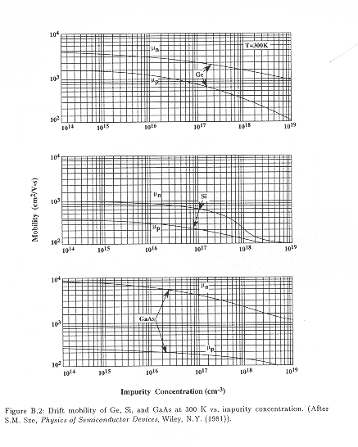
Addressing changes, such as Hf and Zr metal out diffusion into the Si substrate, during thermal annealing is extremely important, since a particular demanding step in the
Fig 18. Drift mobility of Ge, Si and GaAs at 300 oC vs impurity concentration. After Ref. [58].
a)
b
c)

conventional CMOS process flow is the dopant drive in anneals (~ 1050 ºC), which the gate dielectric must undergo without degrading.
Fig. 18 shows the electron and hole drift mobility at 300 K as function of impurity concentration for Ge, Si and GaAs. For Si based devices, the impurity concentration in the channel region must be maintained below ~ 10¹⁶ imp/cm³. Higher concentrations would produce a deleterious effect on the carrier (electron or hole) mobility, as seen in Fig 18b.
It is well known that the electrical performance of silicon-based CMOS transistors is sensitive to impurities in the channel region of the transistor. Because CMOS processing requires high temperature anneals (up to 1050 ºC), it is important to understand the diffusion properties of any metal associated with the gate dielectric into silicon at these temperatures. Impurity out-diffusion into the channel region would likely result in deleterious effects upon carrier mobility. Recent studies of the incorporation of Zr into Si from ZrO₂ have indicated that no significant interdiffusion of Zr occurred within detectible limits by dynamic SIMS after moderate annealing (500-700°C, 5 min., N₂). Ono et al. reported on interfacial reactions occurring in a lineup of rare-earth-metal oxide (Ln₂O₃) between 20 and 30 nm in thickness grown on Si by using a pyrolysis method. It was found that the quantity of Si–O–Ln bonds increases as the postannealing temperature rises, and that this increase depends strongly on the ion radii of the rare-earth elements. That is, metal–oxides with larger ion radii easily form LnSiO (silicate) layers, probably because Si atoms can diffuse easily from the substrates to the films.
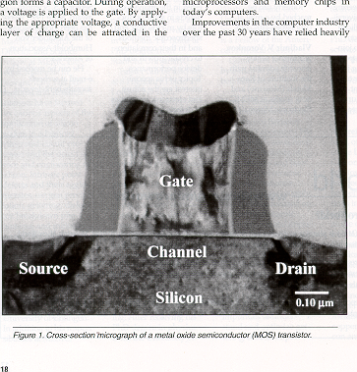
Fig. 19. shows the different components of a transistor affected by metal out diffusion from alternate gate dielectrics: 1) channel region, producing deleterious carrier
1
2
3
4
3
Gate Dielectric
a)
b)
Fig. 19. The different components of a transistor affected by metal out diffusion from alternate gate dielectrics: 1) channel region, 2) interfacial reactions with the polysilicon (or metal) gate, 3) enhanced source and drain leakage, and 4) compromise sidewalls insulation properties.⁶²
mobility and therefore degrading electrical performance, 2) interfacial reactions with the polysilicon (or metal) gate, possible silicide formation 3) enhanced source and drain leakage due to metal diffusion into these regions, and 4) compromise sidewalls insulation properties, mostly metal incorporation in the low-k SiO2, creating pathways for leakage current.
Based on the lack of data on metal out-diffusion from alternate gate dielectrics into Si and furthermore the big impact that any out diffusion would have in the carrier mobility in the channel, this dissertation presents detailed experiments to study metal (Hf, Zr) out diffusion form alternate gate dielectrics Zr and Hf silicates.

REFERENCES

T. Hori, Gate Dielectrics and MOS ULSI’s. (Springer, New York, 1997).
S. M. Sze: Physics of Semiconductor devices, 2nd edition. (Wiley, New York 1981).
M. L. Green, E. P. Gusev, R. Degraeve, and E. L. Garfunkel. Appl. Phys. Lett. 90, 2057 (2001).
M. Hillert, S. Jonsson, and B. Sundman, Z. Metallkd. 83, 648 (1992).
R. J. Hussey, T. L. Hoffman, Y. Tao, and M. J. Graham, J. Electrochem. Soc. 143, 221 (1996).
G. Weidner and D. Kruger, Appl. Phys. Lett. 62, 294 (1993).
P. J. Tobin, Y. Okada, S. A. Ajuria, V. Lakhotia, W. A. Feil, and R. Hegde, J. Appl. Phys. 75, 1811 (1994).
D. M. Brown, P. V. Gray, F. K. Heumann, H. R. Philipp, and E. A. Taft, J. Electrochem. Soc. 115, 311 (1968).
T. Aoyama, K. Suzuki, H. Tashiro, Y. Toda, T. Yamazaki, Y. Arimoto, and T. Ito, J. Electrochem. Soc. 140, 3624 (1993).
T. Aoyama, K. Suzuki, H. Tashiro, Y. Tada, and K. Horiuchi, J. Electro-chem. Soc. 145, 689 (1998).
K. A. Ellis and R. A. Buhrman, J. Electrochem. Soc. 145, 2068 (1998).
K. Krisch, M. L. Green, F. H. Baumann, D. Brasen, L. C. Feldman, and L. Manchanda, IEEE Trans. Electron Devices 43, 982 (1996).
K. A. Ellis and R. A. Buhrman, Appl. Phys. Lett. 74, 967 (1999).
T. Aoyama, H. Tashiro, and K. Suzuki, J. Electrochem. Soc. 146, 1879 (1999).
G. D. Wilk , R. M. Wallace, and J. M. Anthony. Appl. Phys. Lett. 89, 5243 (2001).
See The International Technology Roadmap for Semiconductors, Semiconductor Industry Association; see also http: //public.itrs.net.
G. E. Moore, Electron. Mag. 38, 114 (1965).
Y. Taur, D. Buchanan, W. Chen, D. J. Frank, K. I. Ismail, S.-H. Lo, G. A.Sai-Halasz, R. G. Viswanathan, H.-J. C. Wann, S. J. Wind, and H.-S.Wong, Proc. IEEE 85, 486 (1997).
G. Timp, K. K. Bourdelle, J. E. Bower, F. H. Baumann, T. Boone, Cirelli, K. Evans-Lutterodt, J. Garno, A. Ghetti, H. Gossmann, M. Green, D. Jacobson, Y. Kim, R. Kleiman, F. Klemens, A. Kornblit, Lochstampfor, W. Mansfield, S. Moccio, D. A. Muller, L. E. Ocola, M. O’Malley, J. Rosamilia, J. Sapjeta, P. Silverman, T. Sorsch, D. M. Tennant,W. Timp, and B. E. Weir, Tech. Dig. Int. Electron Devices Meet. p615. (1998).
G. Timp, A. Agarwal, K. K. Bourdelle, J. E. Bower, T. Boone, A. Ghetti, M. L. Green, J. Garno, H. Gossmann, D. Jacobson, R. Kleiman, A. Ko-rnblit,F. Klemens, S. Moccio, M. L. O’Malley, L. Ocola, J. Rosamilia, Sapjeta, P. Silverman, T. Sorsch, W. Timp, and D. Tennant, Tech. Dig. Int.Electron Devices Meet. p1041 (1998).
A. Chaterjee, R. A. Chapman, G. Dixit, J. Kuehne, S. Hattangady, Yang, G. A. Brown, R. Aggarwal, U. Erdogan, Q. He, M. Hanratty, Rogers, S. Murtaza, S. J. Fang, R. Kraft, A. L. P. Rotondaro, J. C. Hu, M.Terry, W. Lee, C. Fernando, A. Konecni, G. Wells, D. Frystak, C. Bowen,M. Rodder, and I.-C. Chen, Tech. Dig. Int. Electron Devices Meet. p821. (1997).
E. H. Nicollian and J. R. Brews, MOS (Metal Oxide Semiconductor) Physics and Technology (Wiley, New York, 1982).
S. M. Sze, Physics of Semiconductor Devices, 2nd ed. (Wiley, New York, 1981).
J. Robertson MRS Bulletin. 27, 217 (March 2002).
S. O. Kasap, Principles of Electrical Engineering Materials and Devices, 2nd ed. (McGraw-Hill, New York, 2002).
G. Lucovsky and B. Rayner, Appl. Phys. Lett. 77, 2912 (2000).
J. Robertson, J. Vac. Sci. Technol. B18, 1785 (2000).
C. Kittel, Solid State Physics. (John Wiley & Sons, New York, 1967) p 759.
D. G. Schlom and J. H. Haeni. MRS Bulletin. 27, 198 (March 2002).
C.J. Taylor, D.C. Gilmer, D. Colombo, G.D. Wilk, S.A. Campbell, J. Roberts, and W.L. Gladfelter, J. Am. Chem. Soc. 121, 5220 (1999).
12. G.B. Alers, D.J. Werder, Y. Chabal, H.C. Lu, E.P. Gusev, E. Garfunkel, T. Gustafsson, and R.S. Urdahl, Appl. Phys. Lett. 73, 1517 (1998).
S. Q. Wang and J. W. Mayer, J. Appl. Phys. 64, 4711 (1988).
K. J. Hubbard and D. G. Schlom, J. Mater. Res. 11, 2757 (1996).
G. Lucovsky, Y. Wu, H. Niimi, V. Misra, and J. C. Phillips, Appl. Phys.Lett. 74, 2005 (1999).
A. Kumar, D. Rajdev, and D. L. Douglass, J. Am. Chem. Soc. 55, 439 (1972).
G. D. Wilk, R. M. Wallace, and J. M. Anthony, J. Appl. Phys. 87,484 (2000).
G. D. Wilk and R. M. Wallace, Appl. Phys. Lett. 74, 2854 (1999).
G. D. Wilk and R. M. Wallace, Appl. Phys. Lett. 76,11 (2000).
R. M. Wallace and G. D. Wilk, MRS bulletin, 192, (March 2002).
G.B. Alers, D.J. Werder, Y. Chabal, H.C. Lu,E.P. Gusev, E. Garfunkel, T. Gustafsson, and R.S. Urdahl, Appl. Phys. Lett. 73 (1998) p. 1517. C.J. Taylor, D.C. Gilmer, D. Colombo, G.D. Wilk, S.A. Campbell, J. Roberts, and W.L. Gladfelter, J. Am. Chem. Soc. 121, (1999) p. 5220.
S.Q. Wang and J.W. Mayer, J. Appl. Phys. 64, 4711 (1988).
L. Bragg, G. F. Claringbull, and W. H. Taylor, Crystal Structures of Minerals, Cornell University Press, Ithaca, p. 185 (1965).
W. B. Blumenthal, The Chemical Behavior of Zirconium, Van Nostrand, Princeton, , pp. 201–219 (1958).
M. Balog, M. Schieber, S. Patai, and M. Michman, J. Cryst. Growth 17, 298 (1972); M. Balog, M. Schieber, M. Michman, and S. Patai, Thin Solid Films 41, 247 (1977); M. Balog, M. Schieber, M. Michman, and S.Patai, ibid. 47,109 (1977); M. Balog, M. Schieber, M. Michman, and S. Patai, J. Elec. Chem. Soc. 126, 1203 (1979).
G. Lucovsky and G. B. Rayner, Appl. Phys. Lett. 77, 2912 (2000).
G. Lucovsky, G. B. Rayner, and R. S. Johnson, Microelectron. Reliab. 41, 937 (2001).
W-J. Qi, R. Nieh, E. Dharmarajan, B. H. Lee, Y. Jeon, L. Kang, K. Onishi, and J. C. Lee. Appl. Phys. Lett.(REFERENCE)
B. C. Hendrix, A. S. Borovik, C. Xu, J. F. Roeder, T. H. Baom, M. J. Bevan, M. R. Visokay, J. J. Chambers, A. L. Rotondaro, H. Lu, and L. Colombo. Appl. Phys. Lett. 80, 2362 (2002).
A. Kawamoto, K. Cho, P. G. Griffin, and R. Dutton, Appl. Phys. Lett. 90, 1333 (2001)
D. L. Kwong and J. M. White, Proceedings of the Sematech FEP PAG Meeting, Austin, Texas, Feb. 2000.
W.-J. Qi, R. Nieh, B. H. Lee, K. Onishi, L. Kang, Y. Jeon, J. C. Lee, V. Kaushik, B.-Y. Neuyen, L. Prabhu, K. Eisenbeiser, and J. Finder, 2000 Symposium on VLSI Technology, IEEE Electronic Devices Society Honolulu, June 2000, p. 16.
J. P. Maria, D. Wicaksana, A. I. Kingon, B. Busch, H. Schulte, E. Garfunkel, T. Gustafsson. J. Appl. Phys. 90, 3476 (2001).
A. Callegari, E. Cartier, M. Gribelyuk, H. F. Okorn-Schnidt, and T. Zabel, J. Appl. Phys. 90, 6466 (2001).
K. L. Hubbard and P. G. Schlom, J. Mat. Res. 11, 2757 (1996)
T. Yamagushi, H. Satake, N. Fukoshima, and A Toriumi, Appl. Phys. Lett. 80, 1987 (2002).
B. K. Park, J. Park, M. Cho, S. Hwang, K. Oh, Y. Han, and D. Y. Yang, Appl. Phys. Lett. 80, 2368 (2002).
J. Park, B. K. Park, M. Cho, S. Hwang, K. Oh, and D. Y. Yang, J. Electrochem. Soc. 149, G89 (2002)
S. M. Sze, Physics of Semiconductor Devices.Wiley, N.Y. 1967.
H. Bracht, MRS Bulletin 25, 22 (2000).
W.-J. Qi, R. Nieh, B.H. Lee, L. Kang, Y. Jeon, K. Onishi, T. Ngai, S. Banerjee and J.C. Lee, IEDM Symp. Tech. Dig., p. 145 (1999).
H. Ono and T. Katsumata, Appl. Phys. Lett. 78, 1832 (2001).
D.G.Schlom and J.H.Haeni, MRS Bulletin 27(3), 198 (2002).

